

**Placement Empowerment Program**

***Cloud Computing and DevOps Centre***

***Install Docker and Run Your First Container:*** *Install Docker and run a basic container (e.g., Nginx). Test accessing the containerized application.*

***Name: VIJAYA NANDANA M Department: CSE***

**Introduction**

In the world of cloud computing and DevOps, containerization plays a crucial role in deploying and managing applications efficiently. Docker, one of the most popular containerization platforms, allows developers to package applications and their dependencies into lightweight, portable containers. This POC focuses on installing Docker and running an Nginx container to understand how containerized applications work.

**Objectives**

* Understand the fundamentals of containerization with Docker.
* Learn how to install and configure Docker on Windows.
* Explore how to pull and run a containerized application.
* Gain experience in managing and troubleshooting Docker containers.
* Demonstrate the accessibility of a running containerized service.

**Step by Step Overview**

**1. Set-up the Docker environment**

* In Google Search for **Docker windows Download**.
* Scroll Down and **Download Docker Desktop**. Complete the installation process.
* Open Command Prompt and run:

**docker –version**

This should return a version number, confirming Docker is installed.

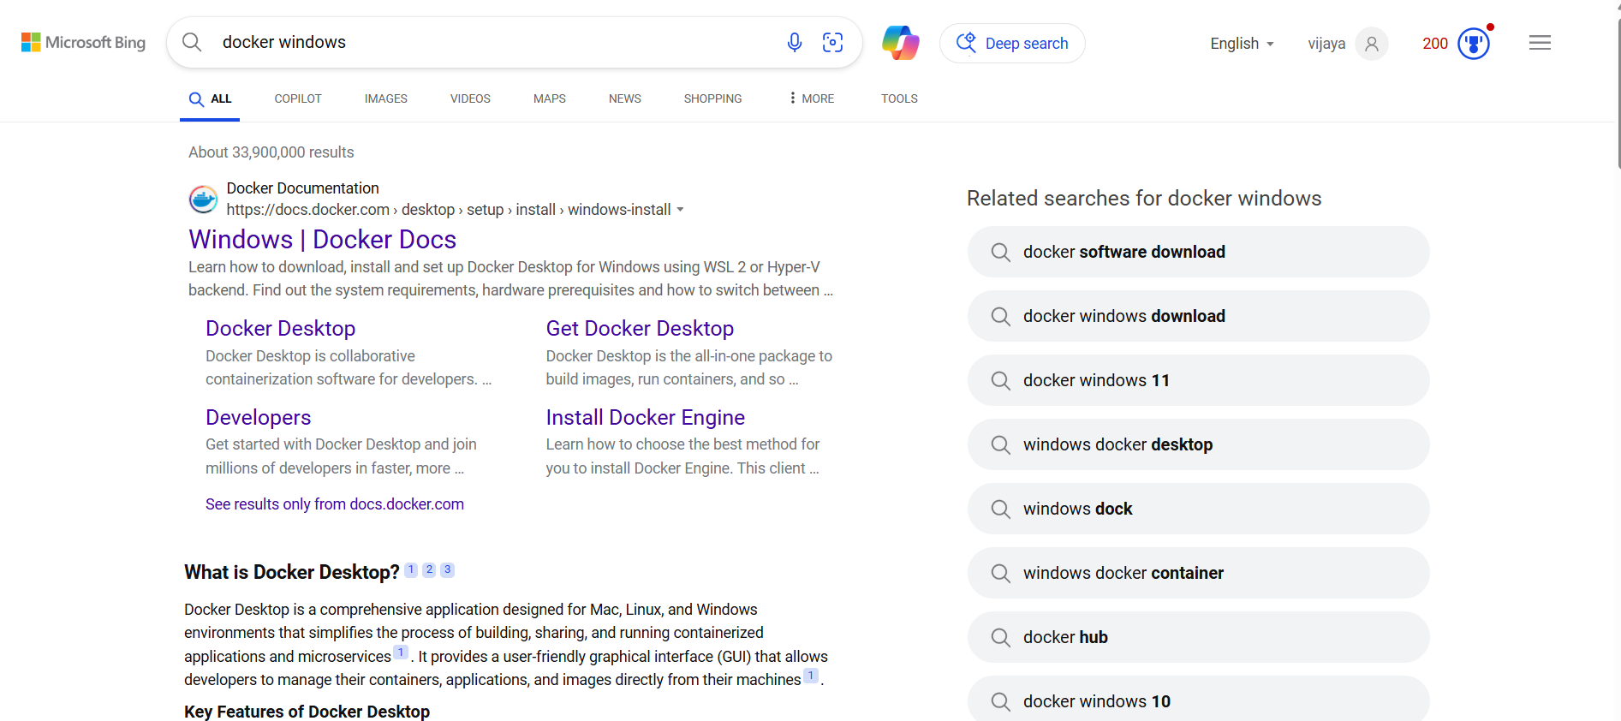

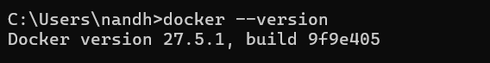

**2. Build the container**

Pull the Nginx Image:

**docker pull nginx**

This downloads the latest Nginx image.

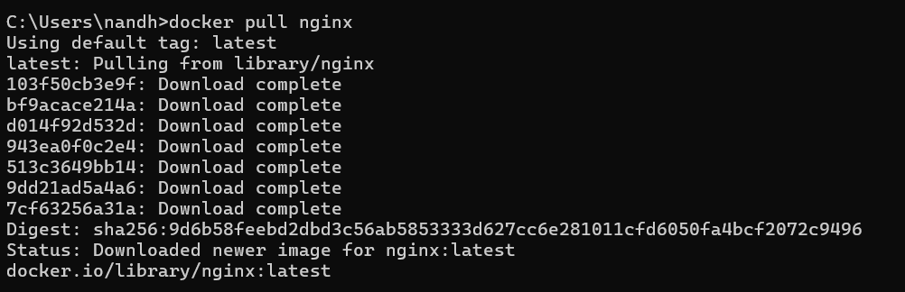

**3. Run the Nginx container**

Run the Nginx Container:

**docker run -d -p 8080:80 --name my-nginx nginx**

1. -d: Runs the container in detached mode (in the background).

2. -p 8080:80: Maps port 80 inside the container to port 8080 on your local machine.

3. --name my-nginx: Names the container my-nginx.



**4. Verify the Running Container:**

**docker ps**

You should see my-nginx running in the list.



**5. Test Accessing Nginx:**

1. Open a browser and go to:

***http://localhost:8080***

1. You should see the default Nginx welcome page.

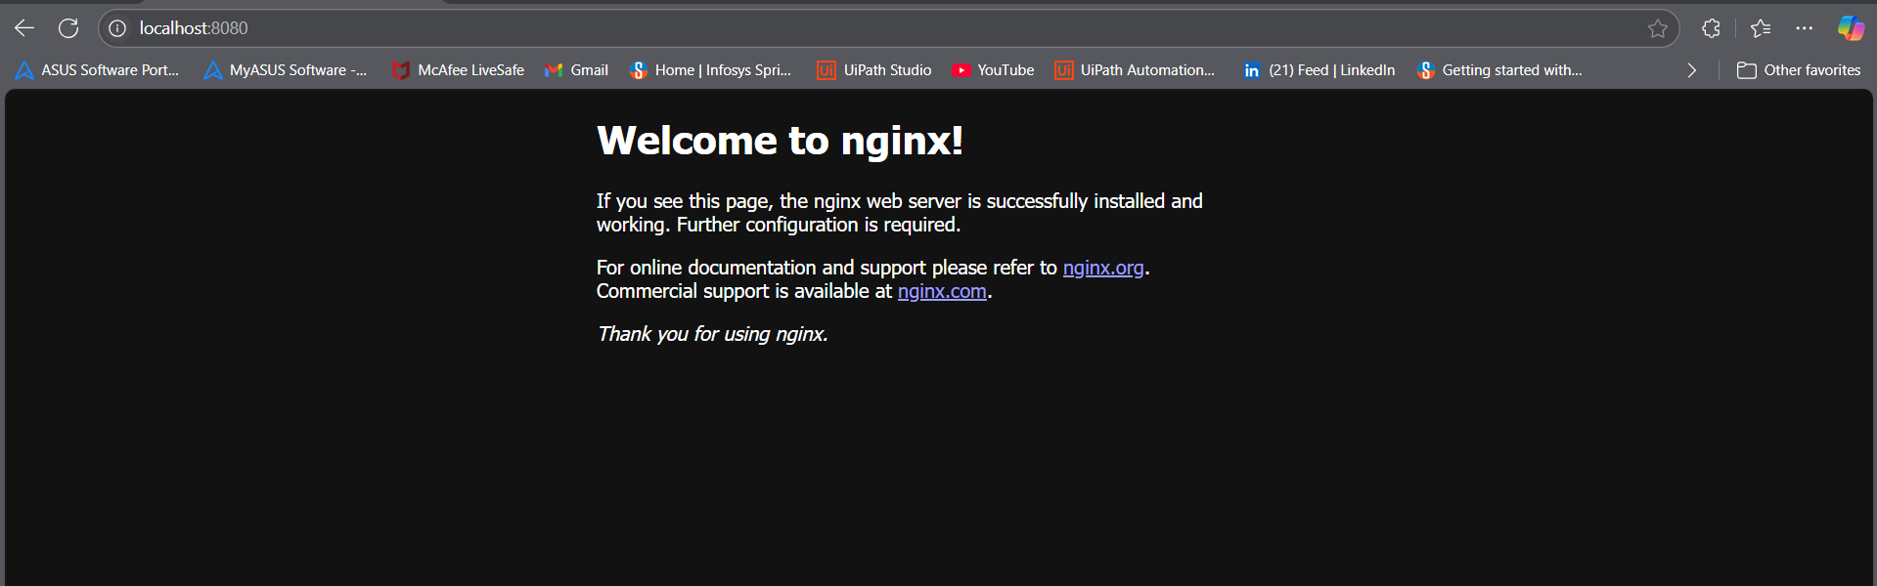

**6**. Stopping and removing the container

* By Opening Docker Desktop App We can see our container running.
* **Stop the container:**

***docker stop my-nginx***

* Remove the container:

***docker rm my-nginx***

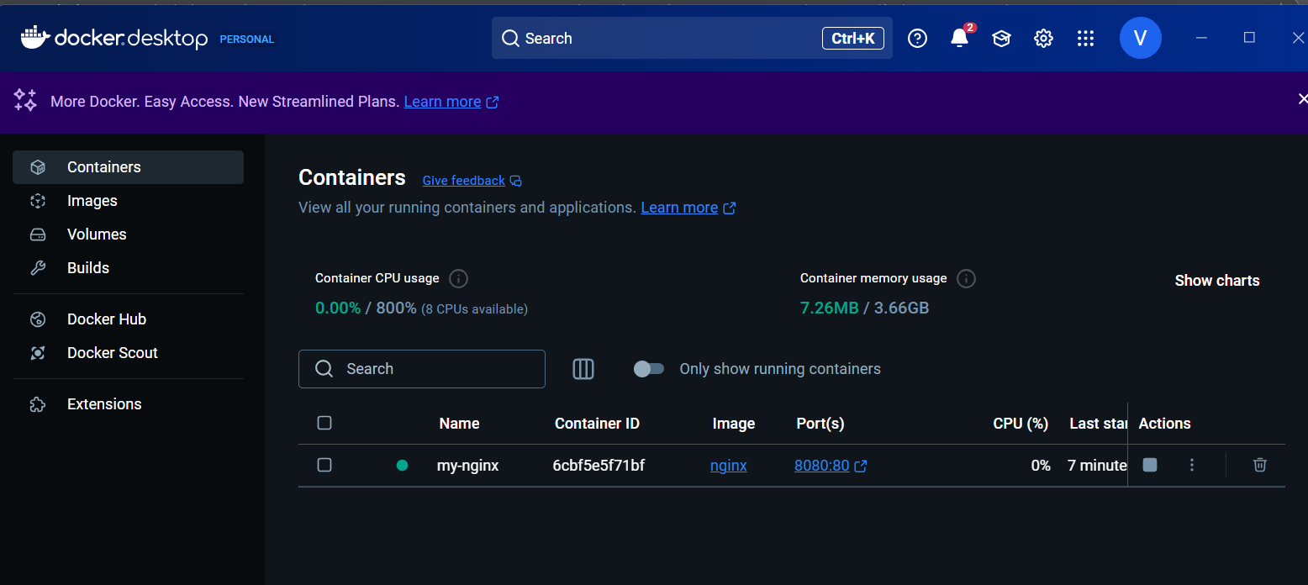

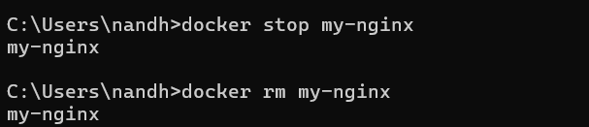

**Outcome:**

* Learn to set up Docker on Windows and prepare the environment for containerized applications.
* Gain hands-on experience in downloading and deploying a web server using Docker.
* Understand how to map ports and access the running Nginx container via a browser.
* Learn essential Docker commands to start, stop, inspect, and remove containers efficiently.
* Explore how Docker simplifies application deployment, enhances scalability, and streamlines DevOps workflows.